**Green Society Public School**

**D-09**

**Ratnanagar-7, Sauraha, Chitwan**

**Second Terminal Examination-2082**

**Class: UKG Time: - 2 hrs. F.M.: 50**

**Sub: Project Work**

|  |
| --- |
| **Name: Roll No.: Sec.:** |
| **­­­­­­­­­­­­ ________________ ______________ OBT.MARKS:**  **INVIGILATOR EXAMINER** |

1. **Colour it. (5)**
2. 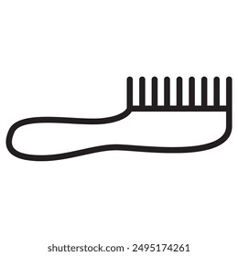**Match the picture with their name. (5)**

Injection

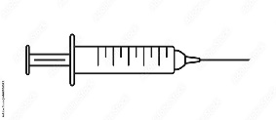Comb

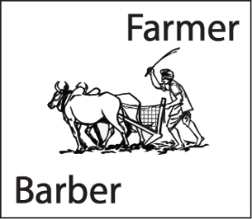Farmer

Zoo

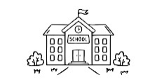School

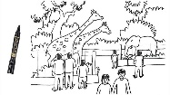

1. **Draw the picture of a house. (10)**
2. 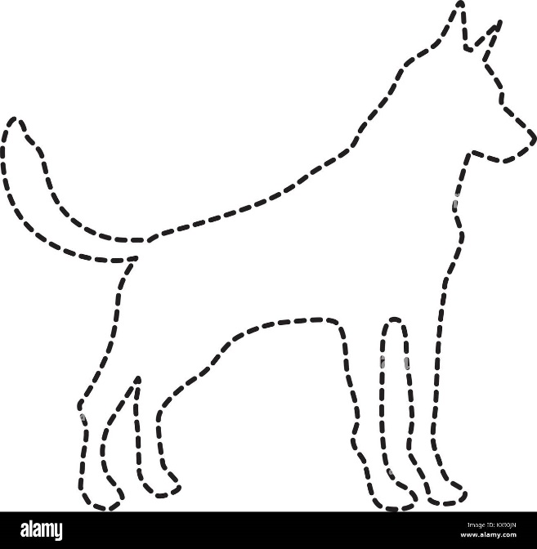 **Join the dotted line and color it. (10)**
3. **Complete the half picture and color it. (20)**

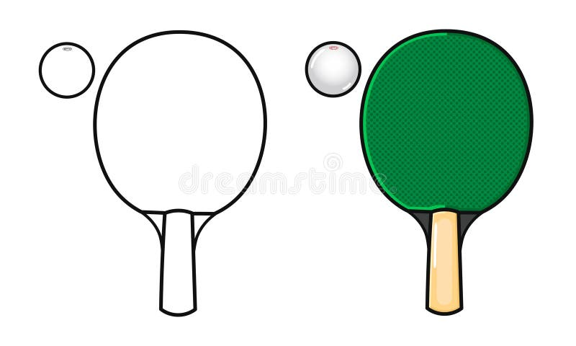

**The End**